**INSTALLATION OF HADOOP**

**INSTALLATION STEPS:**

# 1.INSTALL JAVA 2.INSTALL AND UNZIP HADOOP 3.SETTING UP ENVIRONMENT VARIABLES

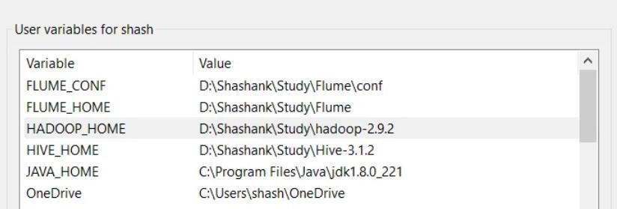

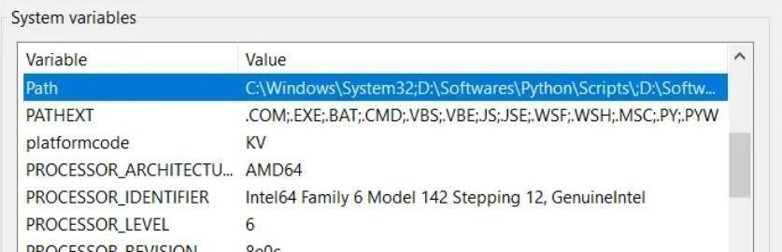

# 4.EDITING CONFIGURATION FILES Core-site.xml

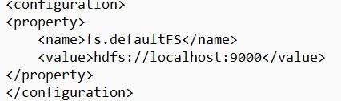

# Hdfs-site.xml

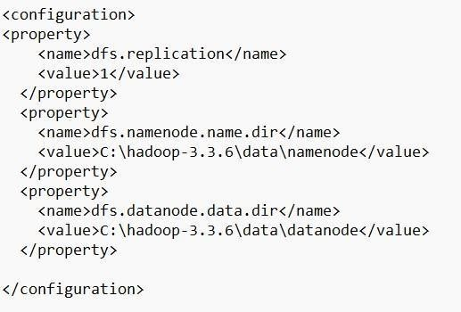

# Mapred-site.xml

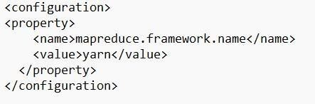

# Yarn-site.xml

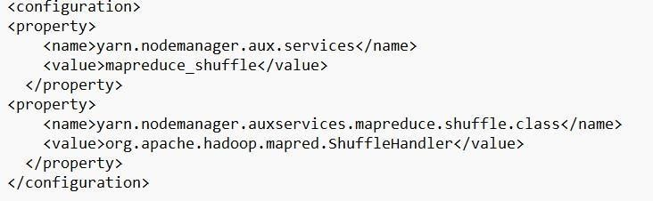

# 5.REPLACE BIN FOLDER

**6.FORMAT NAMENODE AND DATANODE**  hadoop namenode -format hadoop datanode -format

# 7.START HADOOP

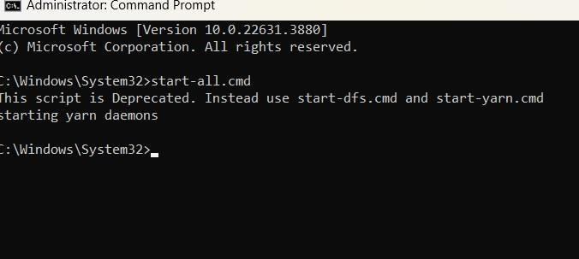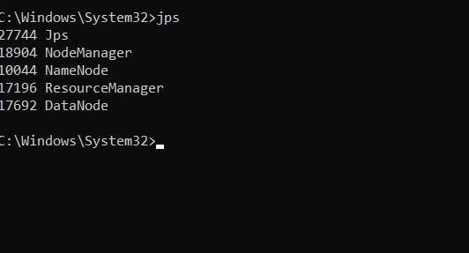

# 8.RUNNING HADOOP

